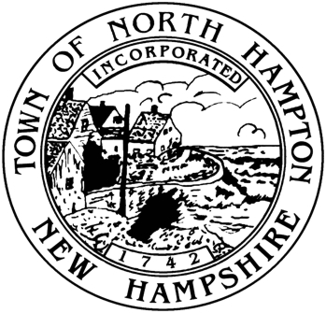

Municipal Offices

233 Atlantic Avenue

North Hampton, NH 03862

Tel: (603) 964-8087

Fax: (603) 964-1514

Jim Maggiore, Chair

Phil Wilson, Vice Chair

Larry Miller, Member

Town of North Hampton, New Hampshire

THE SELECT BOARD

PUBLIC NOTICE

It is possible that a quorum of the Select Board will be present at the meeting of the North Hampton School District on Thursday, October 17, 2013 at 7:00 p.m. The School Board Meeting will take place at the North Hampton School, located at 201 Atlantic Avenue in North Hampton.

A quorum may be present during all or part of the Meeting.

There is no specific Select Board agenda and no minutes will be kept.